Can machine learning price for decline before it happens?

A risk-based approach to fixed and variable fee structure in affiliate marketing

Ian Forbes
Student number: 24064087
UFCE9T-60-M - MSc Data Science
UWE Bristol
August 2026

Abstract
This project asks whether point-in-time transactional and relationship data can identify advertiser groups entering sustained commercial decline early enough to inform renewal pricing, and whether a risk-adjusted fixed/variable fee structure can improve gross profit compared with an affiliate network's current terms.
A point-in-time dataset and forward-looking decline target were built to avoid leakage from the outcome window, and a set of classification models was compared using gross-profit-weighted performance rather than accuracy alone.
The selected Random Forest model increases weighted F1 from 0.416 under the network's current twelve-month rule to 0.626, with most of the improvement driven by recent three-month momentum rather than the wider feature set.
The resulting risk score was translated into a fixed/variable fee curve, compared across five candidate shapes and backtested against realised forward outcomes. The recommended curve produces a +3.82% gross profit improvement against historical terms, increasing gross profit by 16.90% among advertisers that subsequently decline while giving up 2.11% among those that grow.
A hard-threshold approach produced a higher backtested point estimate but was not selected because of fairness and negotiation concerns around the sharp cutoff.
The artefact is intended to support renewal pricing rather than automate it, and a live pilot is proposed as the next step to test how advertisers actually respond to the recommendation.

Declaration
I declare that this report and the accompanying artefact are my own work, and that all sources have been appropriately acknowledged. This work has not been submitted, in whole or in part, for any other assessment at this or any other institution.

Contents
Abstract 2
Declaration 2
1. Introduction 5
Problem context 5
Objective 5
Scope and Contribution 5
2. Literature Review 6
Churn versus gradual decline 6
Locating an affiliate network in the contractual/non-contractual typology 6
B2B churn and relationship variables 6
Profit-driven and value-weighted evaluation 7
Explainability for decision support 7
Risk-based pricing beyond affiliate marketing, and the case against sharp discontinuities 7
Literature Summary 8
3. Design and Approach 8
Artefact User 8
Target definition and client granularity 8
Concentration and the case for value-weighted evaluation 9
Cost-sensitive: tested and rejected 9
Scope of who gets scored 10
4. Implementation 10
Data Sources 10
Feature Engineering 10
Firmographic and Commercial 10
Momentum 10
Publisher 10
Modelling 11
Pricing Formula 11
Reproducibility 12
5. Results and Evaluation 12
Classification performance 12
What drives the predictions 13
Risk bands and severity 14
Predicting severity directly 15
Pricing backtest 16
Generalisation and weaknesses 18
6. Ethical considerations 19
Data Governance 19
Fairness of risk-based repricing 19
Human oversight 20
Where ethics changed the artefact 20
7. Reflection and Planning 20
How the approach developed 20
Supervision and feedback 21
Personal performance 21
8. Limitations 21
9. Conclusions 23
References 24

1. Introduction

Problem context
Advertiser relationships in affiliate networks are priced through a combination of fixed and performance-based fees, and the optimal mix depends on the client’s growth in the network versus how exposed they are to decline.
Pricing relies on historical performance and judgement, which is hard to apply consistently across a large, fast-moving portfolio, where structural decline is difficult to separate from ordinary volatility until it has already happened. This mirrors a wider shift in subscription pricing: SaaS providers have moved towards hybrid pricing, with adoption estimated at 85% of surveyed companies by 2025, up from 46% in 2023 (OpenView Partners, 2023; Metronome and Greyhound Capital, 2025).

Objective
The research question this project addresses is: to what extent can point-in-time transactional and relationship data identify advertisers entering sustained commercial decline, and can the resulting risk score improve renewal gross profit through a risk-adjusted fixed/variable fee structure?
This is addressed through three objectives:
- Build a point-in-time dataset and a decline target that reflect the information actually available at a renewal decision, avoiding any leakage from the outcome window.
- Compare a set of classification models using gross-profit-weighted performance rather than accuracy alone, and identify which features drive the predictions.
- Translate the resulting risk score into a repricing rule and test, on held-out data, whether it protects more gross profit than the network’s current terms.

Scope and Contribution
This differs from conventional churn because the outcome is gradual commercial decline within an ongoing relationship, rather than the client leaving altogether. The setting also sits between the contractual and non-contractual environments discussed in the literature: contractual in structure, but with decline developing more gradually through behaviour. The project does not predict closure or dictate pricing. It produces a risk score and pricing recommendation to sit alongside existing commercial judgement. Existing research mainly focuses on consumer churn or binary B2B churn, which does not fully capture gradual value decline in this type of relationship. The contribution is to apply the idea of partial defection, gradual behavioural decline among otherwise-loyal clients (Buckinx and Van den Poel, 2005), to this setting and use that signal to support pricing decisions rather than trigger retention activity.

2. Literature Review
The literature informing this project falls into five areas: churn and decline prediction, business to business customer value research, profit-driven evaluation, model explainability, and risk-based pricing outside marketing. The fourth matters because a model feeding a live pricing decision needs to be understood by the commercial teams using it. The fifth because the closest parallel to translating a risk score into a differentiated price sits in insurance.

Churn versus gradual decline
Most churn and decline research has developed within retail and e-commerce, applying supervised methods to detect attrition or downward shifts in transactional behaviour, typically using variants of the Recency, Frequency and Monetary (RFM) framework (Hughes, 1994; Sweidan et al., 2022; Shahabikargar et al., 2026). Buckinx and Van den Poel (2005) reframe the outcome rather than the method: in a non-contractual retail setting, defection is rarely sudden, and identifying gradual decline early has more commercial value than waiting for a customer to leave outright; Burez and Van den Poel (2007) show the same early-detection logic still applies in a contractual pay-TV setting, though there the underlying event is a discrete cancellation rather than gradual decline. Buckinx and Van den Poel's reframing, not the consumer setting it was built for, is what this project applies to advertiser performance.

Locating an affiliate network in the contractual/non-contractual typology
Fader, Hardie and Shang’s (2010) typology distinguishes contractual from non-contractual relationships. An affiliate network sits between the two: contractual in that agreements have renewal points, yet the commercial behaviour that matters to pricing behaves more like the latent, gradually observed decline typical of non-contractual settings. This semi-contractual position is what makes partial defection a more appropriate lens than binary churn.

B2B churn and relationship variables
B2B churn research treats the relationship as more structured, drawing on account size, service level and contract history alongside transactional behaviour, and generally finds B2B data noisier and less linear than consumer data (Gordini and Veglio, 2017). The most closely related work is Janssens et al. (2024), who develop a profit-driven, instance-dependent model for B2B churn, weighting prediction errors by “account value”. It still frames the outcome as binary churn rather than gradual decline, which does not solve the problem of this project. Rusdarmono, Sofwan and Lumban Batu (2025) find a related pattern in a different B2B setting - Net Promoter Score, an attitudinal loyalty measure, frequently diverges from RFM-based transactional value, reinforcing the case for behavioural over perceptual signals.

Profit-driven and value-weighted evaluation
Conventional metrics such as accuracy treat every advertiser equally, yet a small share of accounts holds most of the value, so a missed high-value advertiser is far more costly than a missed marginal one. Verbraken, Verbeke and Baesens (2013) address this with an Expected Maximum Profit measure that builds financial consequence into evaluation itself; Lemmens and Gupta (2020) show that ranking by predicted probability alone, without regard to value, can produce technically accurate but commercially ineffective results. Together these justify weighting evaluation in this project by gross profit rather than standard classification metrics alone.

Explainability for decision support
A model feeding a pricing conversation needs to be interpretable by the commercial teams using it. Lundberg and Lee (2017) provide the most widely used method for this, SHAP, used here to explain why an advertiser has been flagged as high risk. Rudin (2019) argues high-stakes decisions are often better served by inherently interpretable models than by ones explained after the fact; this project treats the model as decision support rather than automation, which addresses that concern in part but not fully.

Risk-based pricing beyond affiliate marketing, and the case against sharp discontinuities
A closely related literature sits outside marketing: risk-based pricing in usage-based insurance, where a predictive score is translated directly into a differentiated price. Li et al. (2025) show how risk-based pricing can protect profit while accounting for customer retention, and Xie (2024) shows how behavioural telematics data can be incorporated alongside traditional rating factors, both direct analogues to this project’s design; neither considers a B2B, fixed/variable setting, so the mechanism itself is built for the affiliate-network context rather than adapted from either paper.
A second, related strand addresses not whether a score should be priced but how sharply. Kleven and Waseem (2013) show hard cutoffs in tax and transfer schedules create an incentive to bunch behaviour around the boundary; the American Academy of Actuaries’ Risk Classification Statement of Principles (2014) names “avoidance of extreme discontinuities” as an explicit design principle; Bubb and Kaufman (2011) document abrupt changes in mortgage lending outcomes at credit-score cutoffs; and Bambauer, Zarsky and Mayer (2022) identify this general pattern, a small input change producing a large outcome change, as a fairness concern warranting scrutiny even where the underlying score is predictively valid. A subsequent literature review independently supported the same concern already raised by stakeholders and provides the academic basis for constraining the fee curve.

Literature Summary
This literature therefore supports the project in five ways: reframing decline as gradual rather than binary, which shapes the target definition, locating an affiliate network's semi-contractual position between the typology's opposites, which shapes who the model should and should not score, justifying gross-profit weighting throughout evaluation, providing an insurance-sector precedent for turning a risk score directly into a price, and showing that sharp discontinuities carry fairness and operational risk even where the underlying score is accurate, which is why the final curve is constrained rather than left to optimise unchecked.

3. Design and Approach

Artefact User
The intended user is a pricing executive supporting a renewal procedure rather than an automated pipeline. The wider pricing function’s experience is that low adoption, not model accuracy, has been the more common failure mode when a tool’s output is not framed for commercial teams to act on. Two consequences follow: the output must be interrogable, and must sit alongside judgement rather than override it, particularly for the largest relationships. Informal conversations with the renewal management team leads were positive about the direction, and separate stakeholder conversations reinforced the same point: meaningful drivers of decline, spend commitments, live negotiations and market expansion, sit outside any dataset the model can see, so a score built from commission and publisher data can only be a base indication.

Target definition and client granularity
The unit of analysis is the advertiser group rather than individual programs, reflecting how relationships are managed rather than how programmes are structured technically. An advertiser is labelled as entering sustained decline if forward twelve-month commission falls below 90% of trailing twelve-month commission, tested at 5%, 10% and 15% thresholds. Gross profit plays no part in the label itself, entering only afterward through evaluation weighting, cost-sensitive fitting and pricing. Programme closures within the outcome window are nulled rather than counted as decline, since closure is a different commercial event. This removed 12.4% of the panel.

Concentration and the case for value-weighted evaluation
The portfolio’s value has high concentration of commission - on the January 2025 snapshot, the top 5% of advertiser groups by trailing commission account for 83.5% of the book’s commission, and the top 1% accounts for 62.3% (Gini = 0.936). Evaluation treating advertisers as interchangeable could classify most advertisers correctly and still miss most of the value at risk. Every headline metric is therefore weighted by trailing gross profit. Weighted precision, recall and F1 are used rather than a single metric because the pricing application needs both sides of the error trade-off visible separately.
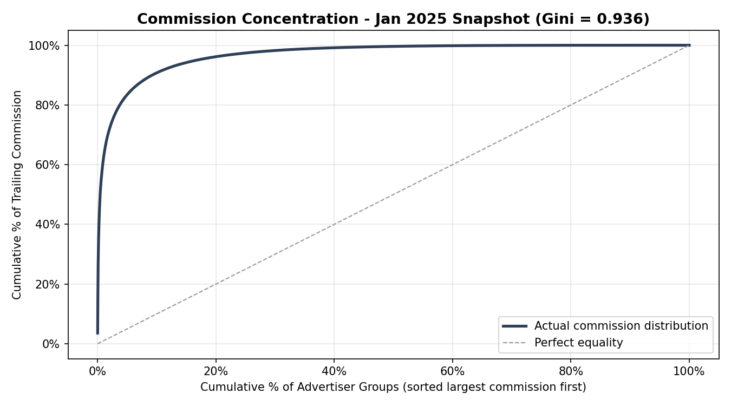
Figure 1. Cumulative concentration curve of trailing commission, January 2025 snapshot (Gini = 0.936).

Cost-sensitive: tested and rejected
A recommendation received during supervision was to weight training loss by advertiser value directly, the instance-dependent approach Janssens et al. (2024) develop for B2B churn, so this was tested. Raw gross profit weights proved unusable in a portfolio this concentrated, collapsing the effective training sample to under 5% of its real size. A ninety-ninth percentile cap was used instead, the least aggressive transform clearing a minimum 10% effective-sample criterion defined before the comparison was run. A paired cross-validation found the effect null for logistic regression and random forest, and significantly harmful for XGBoost. Models are therefore fitted with no weighting - weighting enters only through threshold choice and evaluation.

Scope of who gets scored
The strongest momentum feature, three-month year-on-year growth, is missing for a meaningful share of advertiser groups. Programmes with under fifteen months of history cannot support a same-quarter comparison and are excluded from algorithmic scoring in favour of standard renewal review. A second, small, established population is missing the ratio only as a construction artefact of a low-commission quarter; these are scored instead by a fallback model built on features that do not depend on it. The remaining in-scope population, 75.8% of advertiser groups and 95.0% of gross profit, is what all headline results refer to.

4. Implementation

Data Sources
The dataset is built from the network’s internal transactional and fixed-fee reporting tables, taken as a single point-in-time snapshot at the start of January 2025, with forward twelve months of commission carried solely to construct the outcome label. Dataset construction and sensitivity checks use an eighteen-month rolling panel, however the modelling uses only the single month snapshot. There are standard rules applied that only confirmed and pending transactions are kept, the latter having a recognition rate applied, and closed legacy programmes from a prior platform migration are dropped. After restricting to groups with positive trailing commission, the dataset contains 15,247 advertiser group rows and 82 columns, of which 40 are model features.

Feature Engineering
There are three families of features:

Firmographic and Commercial
These features describe the relationship’s shape including log-transformed commission and gross profit, effective take rate, fixed-fee share, programme age and count, service/platform tier and commission size tier.

Momentum
These features describe trajectory such as year-on-year growth over nested windows, negative-growth and consecutive-decline counts, commission volatility, quarter-on-quarter acceleration, and trend-reversal flags

Publisher
Publisher features describe funnel-type commission mix and its year-on-year shift, testing an exploratory hypothesis raised by this project rather than the literature: that a more diversified publisher base makes an advertiser more resilient.
Two decisions were made on the data - momentum comparisons are made year-on-year, not against the immediately preceding period, to avoid flagging every advertiser as declining each January; and the nested year-on-year windows, strongly correlated with the three-month window, were excluded from the feature set as carrying no independent information. Missing values use explicit missingness flags alongside neutral imputation, so absence remains visible as information.

Modelling
There are a range of models tested from simple to more complex:
- 12 month year-on-year rule - the current business model and therefore baseline
- 3 month year-on-year
- Logistic regression
- Random Forest
- XGBoost (Chen and Guestrin, 2016)

Each model is fitted on the full feature set, and then a reduced 2 feature simple model.
Data is split 70/30 stratified, into training and hold-out evaluation sets. Every threshold is tuned on training only by maximising gross-profit-weighted F1. The model carried forward is selected by gross-profit-weighted AUC since the risk score itself, not only the binary flag, feeds the pricing formula. The hold-out set is also used to select the pricing curve so it functions as a model-selection set rather than an untouched test set. An out-of-time test applies the frozen model to a later window to measure the stability.

Pricing Formula
The repricing rule shifts a client towards a higher fixed-fee proportion as decline risk rises and the variable rate is back-solved to reproduce the clients baseline gross profit. Both the old and new terms are then applied to the forward 12 month commission. The floor and ceiling fixed fee proportions are anchored to the training population’s risk bands.
Five candidate curve shapes were compared:
- Isotonic Regression based on the severity gradient
- Simple linear ramp based on risk score
- Constrained logistic curve
- Five tier quintile step
- Hard Threshold - included for measurement but discarded on business principles
A search for optimal logistic curve revealed a convergence on the hard threshold model (midpoint 0.52, steepness 750, +4.74% GP uplift, but 97.7% of clients within two percentage points of the floor or ceiling). Method E, fitted directly, lands similarly (+4.712%), confirming the two are effectively the same object, which both stakeholder review and the discontinuity literature argue against regardless of gross profit.
Method C therefore imposes a concentration constraint - Method D sends its bottom and top quintiles to the extremes by construction, 40% of the book, and that rate becomes the cap for C. Among every combination satisfying it, the one with the highest training gross profit is selected (landing at midpoint 0.51, steepness 30, +4.21% uplift and 39.9% concentration), so roughly 60% of clients receive a recommendation more than two percentage points from either extreme. The 40% cap and tolerance are design choices anchored to Method D, not statistically estimated.

Reproducibility
Notebook 01 creates the processed modelling dataset. Notebooks 02–05 reload this dataset and rebuild the models they require internally, so model outputs are not passed between notebooks.

5. Results and Evaluation

Classification performance
All headline results are gross-profit-weighted and measured on the 3,174-advertiser hold-out set. The full in-scope population contains 10,578 advertiser groups with a 50.9% decline rate, split 7,404/3,174 under stratification.
Against the twelve-month rule used in current practice, weighted F1 increases from 0.416 to 0.626 for the selected random forest model, which was chosen using weighted AUC (0.638). The main improvement comes from recall. The current twelve-month rule identifies around 35p of every £1 of gross profit that later declines, compared with around 89p for the fitted model, while precision remains broadly unchanged.
Most of this improvement comes from recent momentum rather than the wider feature set. Moving from the twelve-month rule to the raw three-month year-on-year rule adds 0.046 to weighted F1, while fitting and tuning a model on that signal adds a further 0.163. The remaining 38 features add only 0.002, meaning the reduced model captures around 99% of the improvement over current practice.
The full model is still carried forward because the difference becomes more important once the predictions are used for pricing. The reduced model produces 1,411 false positives holding €19.02 million of trailing gross profit, compared with 1,294 false positives and €16.46 million for the full model. This is 8.3% fewer false positives and 13.4% less gross profit incorrectly flagged as at risk. As false positives carry a real cost under the pricing approach, this difference is commercially meaningful.
Both the classifier and final pricing curve were selected using the same hold-out population rather than a separate validation set.
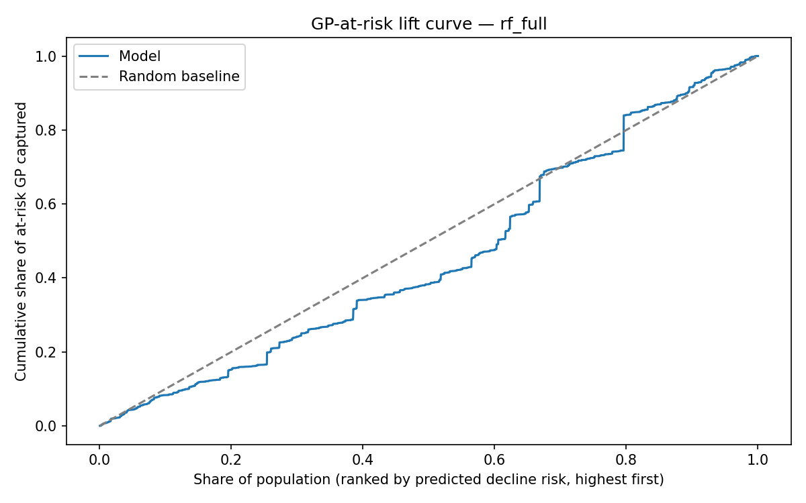
Figure 2. Cumulative gain (lift) curve for the recommended full Random Forest model on the hold-out set, gross-profit-weighted.

What drives the predictions
SHAP analysis (Lundberg and Lee, 2017) shows that the model is driven mainly by momentum. Seven of the ten most important features are momentum measures, led by three-month year-on-year growth, while only two publisher features and one firmographic feature appear in the top ten.
Permutation importance was added as an independent out-of-sample check after supervision discussion around the limitations of relying on SHAP alone. It confirms that three-month momentum is the strongest signal, although two publisher-mix features rank more highly than they do under SHAP. The original hypothesis that publisher diversification would provide a strong additional signal is therefore only partly supported.
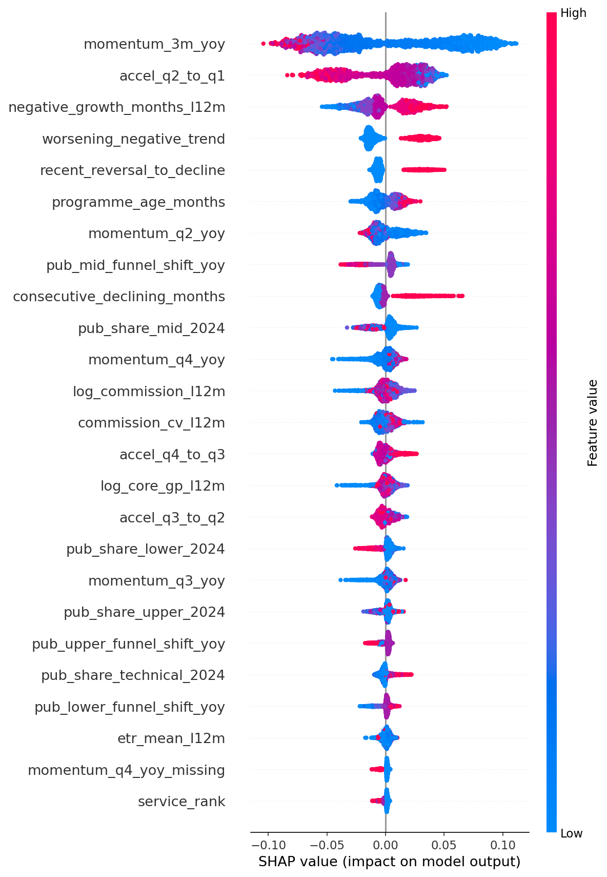
Figure 3. SHAP feature importance for the recommended model; momentum features dominate the top ten.

Risk bands and severity
Grouping advertisers by predicted risk shows a clear ordering in the realised outcome. The decline rate rises from around 30% in the lowest populated risk band to 100% in the highest. This supports the score as a useful ranking of risk, although it is not treated as a claim of fully calibrated probabilities.
An unexpected result appears when looking only at advertisers that subsequently decline. Average severity becomes worse as predicted risk rises, moving from around -43% in the lower bands to around -76% in the highest.
The highest-risk advertisers also show strong concentration of actual decline. The top 5% by predicted risk have an 89.5% weighted decline rate and the top 10% have an 85.8% rate, compared with a 45.1% GP-weighted base rate.
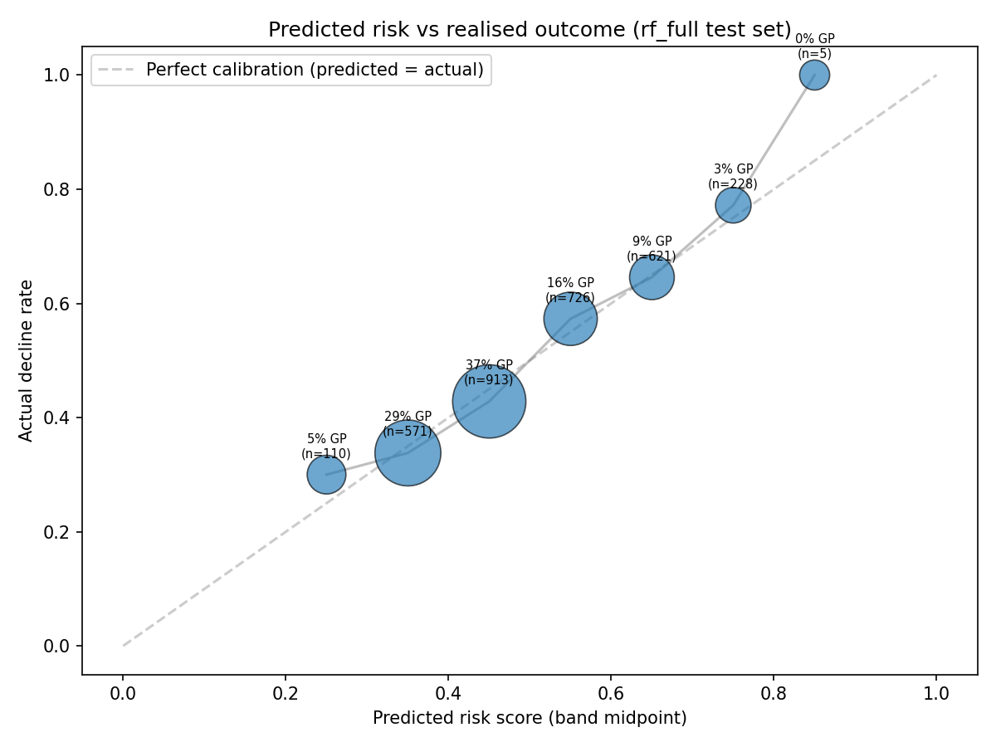
Figure 4. Actual decline rate by predicted-risk band (bubble size = share of gross profit), against the perfect-calibration line.

Predicting severity directly
A separate extension tested whether the model could predict how much an advertiser would decline rather than only whether decline would happen. The severity target was winsorised between -95% and +300%, affecting 1,065 rows, or 10.07% of the population.
At an individual-client level the result is weak. All four fitted models have a lower (better) whole-population mean absolute error than a naive prediction of zero change, but the margin is small. The fitted models perform somewhat better on directional accuracy, loss capture and ranking, capturing around 13% to 34% of realised lost value and producing Spearman correlations of around 0.23 to 0.30.
The relationship is much clearer when advertisers are grouped by classification risk. In the 70-80% risk band, for example, mean actual severity is -34.25% compared with a mean prediction of -32.51%. The 80-90% band contains only five clients and is not treated as reliable.
A permutation test was used to test whether this band-level pattern could reasonably have arisen by chance. The observed correlation of 0.9711 exceeded 1,999 of 2,000 shuffled results, giving p = 0.0005.
The conclusion is therefore narrower than originally intended. Severity is too noisy to use as an individual pricing input, but the band-level pattern provides evidence that the classification score carries information about magnitude as well as direction. Severity is tested as Method A in the pricing comparison but is not used in the final selected curve.
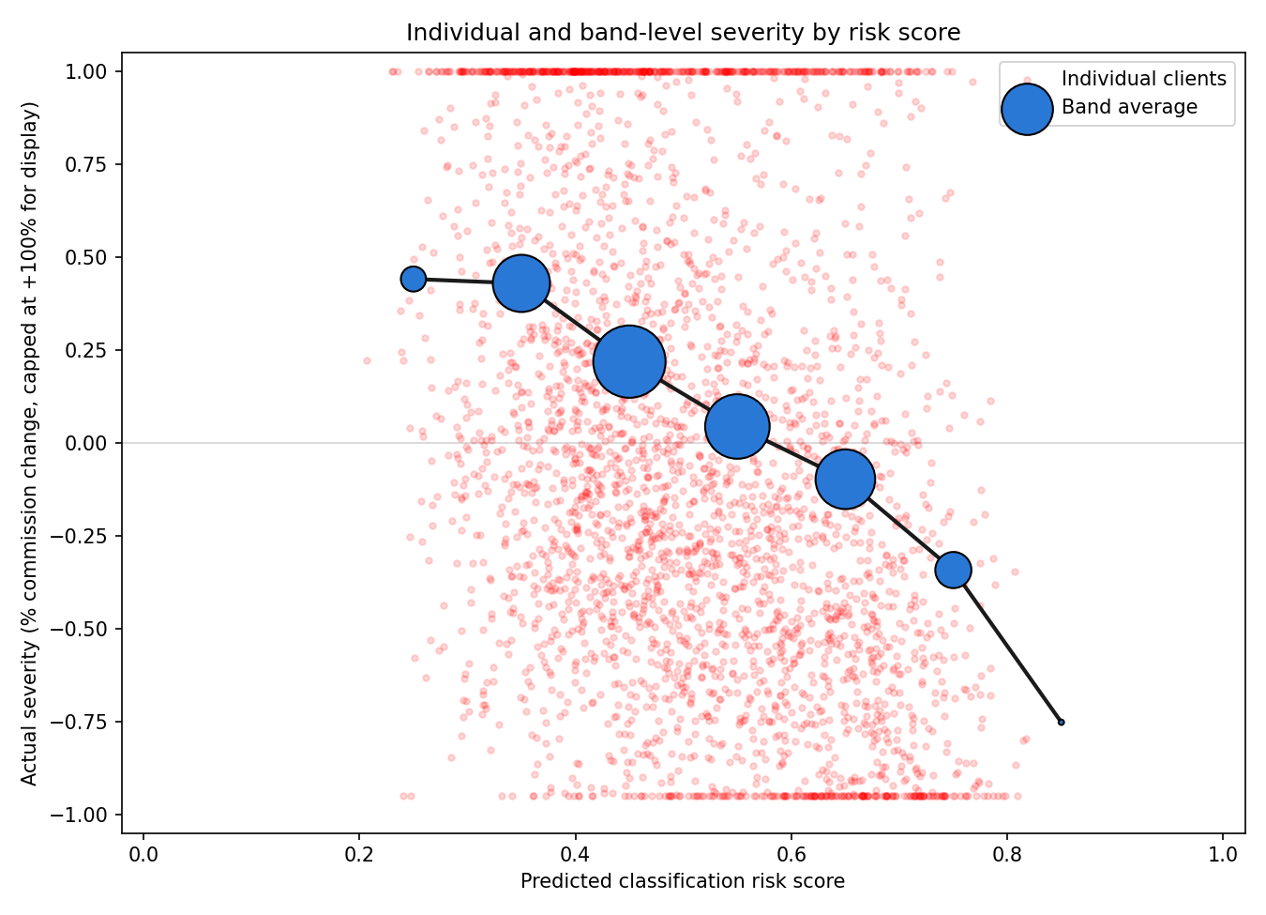
Figure 5. Individual-client severity (red) is noisy across the full risk range; the band average (blue) shows a clear declining relationship with predicted risk.

Pricing backtest
Applying the selected repricing rule to the hold-out population produces an additional €1,494,966 of gross profit, equivalent to +3.82% against the old terms. A fully variable comparator also improves gross profit, but by less: +€513,824, or +1.31%. This suggests the value comes from changing the balance of fixed and variable exposure according to predicted risk rather than simply reducing fixed fees across the whole portfolio.
The result also behaves in the expected direction when split by realised outcome. Advertisers that subsequently decline produce a +16.90% improvement in gross profit, while advertisers that grow give up -2.11%. This trades some growth-side upside for greater protection against decline.
Five pricing curves were compared using the hold-out population with bootstrap confidence intervals. Method B returns +1.03% (CI -1.16 to +3.05), Method D +3.32% (CI +0.88 to +5.71), Method C +3.82% (CI +0.93 to +6.48), and Method E, the hard threshold, produces the highest point estimate at +4.26% (CI +1.00 to +7.27).
Method C is therefore not selected because it produces the highest backtested result. Method E performs better on the point estimate, but it creates a sharp break where clients on either side of the cutoff receive very different fee structures. This was reviewed with senior internal stakeholders, who considered that unsuitable for negotiation and risk management, and the literature provides independent support for avoiding this type of discontinuity.
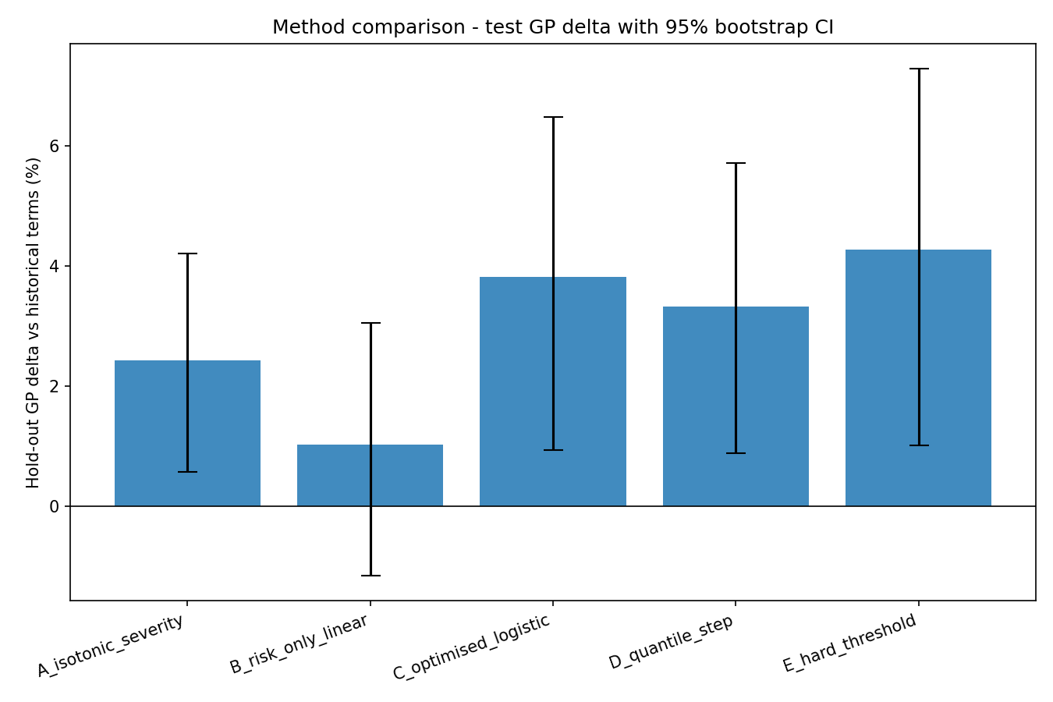
Figure 6. Hold-out gross-profit uplift by candidate curve (A-E) with bootstrap confidence intervals; Method C selected despite not having the highest point estimate.

The confidence intervals for C, D and E overlap substantially, so the results do not establish that one of these methods is statistically superior to the others. Method C is retained because it gives a continuous pricing response, performs strongly on the hold-out population, and has the smallest growth-side cost among the four business-eligible methods at -2.11%.
The selected Method C has 39.9% concentration, effectively the same as Method D’s 40%, but retains a continuous response across the risk range. This costs around 0.52 percentage points of training uplift compared with the unconstrained optimum.
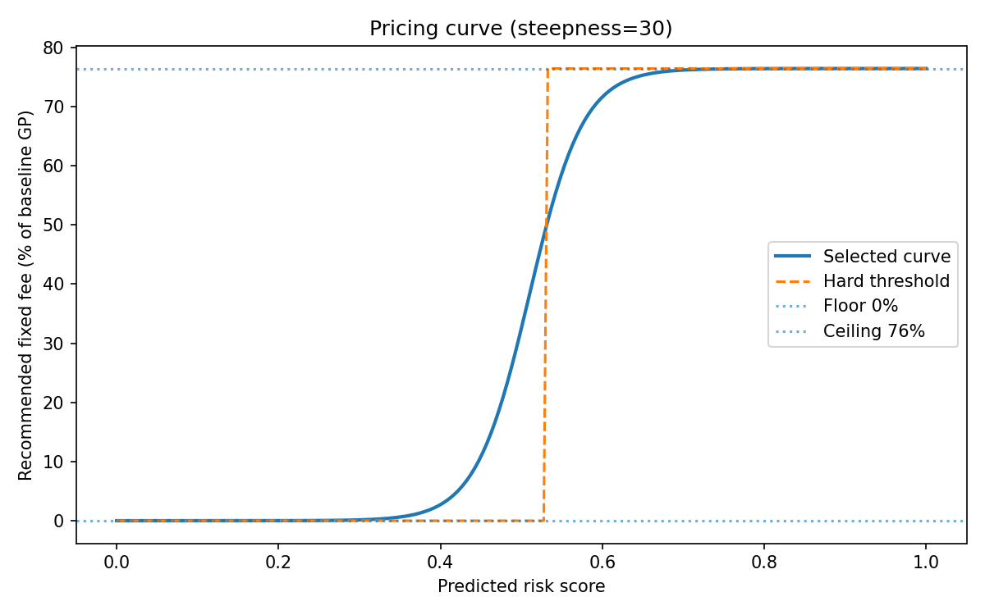
Figure 7. Selected fee curve (Method C): fixed-fee share as a function of predicted decline risk, midpoint 0.51, steepness 30.

The backtest should not be interpreted as a forecast of the exact return from implementation. It applies alternative terms to realised historical outcomes and does not capture how a client may negotiate, renew or change behaviour after receiving those terms. The median gross profit swing is 2.29% of client spend, rising to 15.25% at the 90th percentile. Larger and higher-risk clients are intended to remain subject to deal-desk judgement rather than automatic repricing, although this governance step is not currently implemented in the artefact.

Generalisation and weaknesses
The frozen classifier was also applied to 31,560 advertiser-group observations from April to June 2025, a later period not used during training. Weighted F1 increases slightly from 0.626 on the original hold-out set to 0.639 out-of-time, providing no evidence of performance deterioration over this period.
A separate point-in-time sensitivity test removes three features that are only available as current snapshots rather than historically dated values. The effect on weighted F1 is 0.003, suggesting these fields do not materially drive the model result.
Performance is weaker among the largest advertisers. AUC is 0.699 for the smallest tier but falls to 0.612-0.654 across the larger tiers, which together hold around 96% of gross profit. This supports keeping the model as decision support rather than an automated pricing rule.
The fallback model for the small population without a valid three-month momentum ratio achieves F1 of 0.506 and AUC of 0.738. With only 474 advertisers and near-total recall, these results are treated as directional rather than equivalent evidence to the main model.

6. Ethical considerations

Data Governance
The dataset is entirely commercial from internal reporting systems, containing no personal or consumer data. Data never leaves the employer’s own systems, individual advertisers are anonymised in this report, and the one case investigated to explain an unusual result is also referred to anonymously.

Fairness of risk-based repricing
Increasing the fixed-fee share as predicted risk rises creates a clear fairness question: is it reasonable to ask more of clients that may already be declining?
There is a business justification for doing so. An affiliate network carries a significant fixed infrastructure cost in building and maintaining the platform, tracking, reporting and operational capability that clients have access to. A decline in commission does not necessarily mean those underlying resources are no longer being provided or used. A more fixed structure therefore provides some protection against the network continuing to carry those costs while revenue from the relationship falls.
The pricing rule is also designed to avoid simply charging struggling clients more. It is ETR-neutral at the starting point, so the new terms reproduce the client’s historical gross profit and effective take rate at their existing level of commission. The change is therefore in how future risk is shared between fixed and variable fees, rather than an immediate increase in price.
A further control is placed on the shape of the curve. Without a constraint, optimisation pushes 97.7% of clients close to either the fee floor or ceiling, effectively creating a hard threshold. This was tested separately as Method E and rejected because a client just above the boundary could receive a very different structure from one just below it, while a borderline client could be treated similarly to an extreme-risk client.
The final Method C therefore limits the proportion of clients close to the two extremes to 40%, matching the concentration produced by Method D. The selected curve reaches 39.9%, leaving around 60% of clients on an intermediate recommendation. The 40% limit is a design judgement rather than an empirically estimated fairness threshold, but it provides a practical control against the pricing rule becoming unnecessarily extreme.

Human oversight
The artefact supports pricing judgement rather than replacing it. It produces a risk score and recommended starting position, while larger and strategic clients would remain subject to normal deal-desk negotiation. Younger clients without enough history for reliable momentum features are left unscored. This is important because material information such as commercial commitments, market changes and live negotiations remains outside the model. Human review therefore remains part of the proposed deployment design.

Where ethics changed the artefact
Ethical considerations also changed the analysis itself. A large strategic false positive was retained despite materially reducing the backtest rather than removed after its outcome was known. Clients falling to zero commission were reinstated because excluding them would remove an important source of commercial downside. Finally, the highest-performing hard-threshold method was rejected because its sharp boundary was considered disproportionate.

7. Reflection and Planning

How the approach developed
A decision log was kept throughout the project so that changes in direction were recorded as they happened rather than reconstructed afterwards.
One early example was clients whose commission fell to zero without a formal closure record. These were initially excluded, but this was reversed because they represent exactly the type of commercial downside that fixed-fee protection is intended to cover.
The severity work also changed as the evidence developed. It initially looked like a fairly weak negative result at an individual-client level. A later permutation test showed that the relationship was much stronger when clients were grouped into risk bands, with p = 0.0005. The conclusion therefore became more specific: severity is too noisy to use for individual pricing, but there is a genuine band-level relationship.
The pricing curve went through the biggest change. The first approach used the severity-based isotonic curve, Method A, but this was later tested against alternative pricing structures. When the logistic curve was optimised without constraints, performance continued to improve as the curve became steeper until it was effectively acting as a hard threshold. Rather than leave this hidden inside Method C, the threshold was added as Method E and tested directly.
Method E produced the highest point estimate, but stakeholder feedback and the literature both raised concerns about using such a sharp cutoff in practice. Method C was therefore revised with an explicit concentration constraint and selected as the final recommendation. Its result is lower than Method E on the point estimate, but the confidence intervals overlap substantially, so the evidence does not support describing the difference as clearly measurable.

Supervision and feedback
After discussions with Hisham, several parts of the analysis were extended or challenged. An early recommendation was to move beyond classification and test whether the likely severity of decline could also be predicted. This ultimately proved too noisy at individual-client level to use in pricing, but the band-level relationship was useful and provides a clear area for future work.
Hisham also questioned relying on SHAP alone, which led to permutation importance being added as an independent check. When the first results appeared to conflict, investigation showed this was caused by the evaluation metric rather than genuine disagreement between the methods. He also challenged whether false positives carried a meaningful commercial cost, leading to the direct comparison that supported carrying the full model forward.
Separate business feedback also shaped the final pricing design. Two internal managers raised concerns about the hard-threshold option, leading to the constrained Method C rather than the unconstrained optimum.

Personal performance
Keeping a decision log made it easier to distinguish ideas that were tested from those eventually retained. One useful lesson came from an early comparison between the reduced and full classifiers, where I mistakenly reused an already-fitted pricing curve and obtained identical totals. Refitting the full downstream pipeline separately for each classifier corrected the comparison and reinforced that downstream models need to be rebuilt when upstream inputs change.

8. Limitations
The main limitation is that the model identifies patterns associated with decline without explaining why they occur. Budget changes, strategy shifts, competitor activity and restructuring are not visible in the transactional data.
The strategic advertiser discussed earlier is a good example. The model flagged the client as high risk based on its historical behaviour, but the advertiser later grew by more than twenty times following a new revenue line and market expansion that could not have been known from the available data. This single client was large enough to move the overall backtest result by roughly a fifth. The risk score should therefore be treated as a statistical signal to support judgement, rather than a causal explanation or a fully calibrated probability.
There is also a point-in-time limitation in three of the features, which are only available as current snapshots rather than historically dated values. A sensitivity test removing these fields changes weighted F1 by only 0.003, suggesting the impact is small, but it cannot be assumed to be zero.
The fallback model is another weaker part of the artefact. It covers 474 established advertisers where the main three-month momentum ratio cannot be calculated, but it has not been through the same fold-stability testing as the main classifier. Its results are therefore treated as directional rather than equivalent evidence.
The pricing result is also a backtest rather than a live test. It shows what would have happened if the proposed terms had been applied to the commission outcomes that were later observed. It cannot show whether a client would have renewed, negotiated differently or changed its behaviour after being presented with those terms. A live pilot would be needed to test this.
Both the classifier and pricing curve are built using one affiliate network and a relatively narrow time period. The out-of-time test provides evidence that the classifier remains stable over a later period, but this does not show that the same result would hold under a different client mix, vertical mix or wider economic environment.
A further limitation is that the same 3,174-advertiser hold-out population is used to compare both the classifiers and the candidate pricing curves. This is not target leakage, as the hold-out clients are not used to fit the models, but the data is still used to help select the final approach. The reported result is therefore likely to be more optimistic than it would be on a completely untouched final test set.
This is particularly relevant to the pricing comparison. Method E has the highest point estimate, while Method C has overlapping confidence intervals with both D and E. The evidence therefore does not show that C is statistically better than either. C is selected because it provides continuous differentiation while retaining a strong backtested result and avoiding the sharp threshold produced by Method E. Its concentration of 39.9% is effectively the same as Method D's 40%, rather than meaningfully lower. A separate final validation set, only opened once both the classifier and pricing curve had been fixed, would provide a stronger test but was not available within this project.
Finally, the concentration constraint used for Method C is itself a design decision. The 40% limit is anchored to the behaviour of Method D, while the definition of being close to an extreme, within two percentage points of the floor or ceiling, is also a stated judgement rather than something estimated from the data. Different choices for either of these values could lead to a different logistic curve being selected.

9. Conclusions
The project shows that sustained commercial decline can be identified in advance using transactional data. Weighted F1 improves from 0.416 under the current twelve-month rule to 0.626 for the selected model. Most of this improvement comes from recent three-month momentum, although the full model remains useful because it produces a stronger risk gradient and reduces the gross profit held within false positives.
Predicting the exact size of decline is less successful. Individual severity estimates are too noisy to use for pricing, although a statistically supported relationship appears at risk-band level. Severity is therefore supporting evidence rather than an input to the final recommendation.
The selected pricing approach produces a +3.82% backtested gross profit improvement, equivalent to €1.49 million. The hard-threshold method produces a higher point estimate, but Method C is preferred because it provides continuous differentiation and is more practical for commercial use. This illustrates an important finding from the project: the approach that maximises a historical optimisation objective is not necessarily the most suitable one to deploy.
The next step is a live pilot to test how advertisers actually respond to the recommendation. Further work should also strengthen validation of the fallback segment, rebuild the undated features and capture the outcomes of real pricing decisions. This feedback would provide better evidence for future versions of both the risk model and the pricing recommendation than simply adding further model complexity.

Word count: 5,784 words (main body text excluding assessment title, abstract, reference list). An estimated further 190 words appear as labels and legends within the seven embedded figures.

References
American Academy of Actuaries (2014) Risk Classification Statement of Principles [online]. Washington, DC: American Academy of Actuaries, Committee on Risk Classification. Available from: https://www.actuarialstandardsboard.org/wp-content/uploads/2014/07/riskclassificationSOP.pdf [Accessed 25 July 2026].
Bambauer, J.R., Zarsky, T. and Mayer, J. (2022) When a small change makes a big difference: algorithmic fairness among similar individuals. UC Davis Law Review. 55 (4), p. 2337.
Bubb, R. and Kaufman, A. (2011) Securitization and Moral Hazard: Evidence from Credit Score Cutoff Rules. Public Policy Discussion Paper No. 11-6. Boston: Federal Reserve Bank of Boston.
Buckinx, W. and Van den Poel, D. (2005) Customer base analysis: partial defection of behaviourally loyal clients in a non-contractual FMCG retail setting. European Journal of Operational Research, 164(1), pp. 252-268.
Burez, J. and Van den Poel, D. (2007) CRM at a pay-TV company: using analytical models to reduce customer attrition by targeted marketing for subscription services. Expert Systems with Applications, 32(2), pp. 277-288.
Chen, T. and Guestrin, C. (2016) XGBoost: a scalable tree boosting system. In: Proceedings of the 22nd ACM SIGKDD International Conference on Knowledge Discovery and Data Mining. San Francisco, 13-17 August 2016. New York: ACM, pp. 785-794.
Fader, P.S., Hardie, B.G.S. and Shang, J. (2010) Customer-base analysis in a discrete-time noncontractual setting. Marketing Science, 29(6), pp. 1086-1108.
Gordini, N. and Veglio, V. (2017) Customers churn prediction and marketing retention strategies: an application of support vector machines based on the AUC parameter-selection technique in B2B e-commerce industry. Industrial Marketing Management, 62, pp. 100-107.
Hughes, A.M. (1994) Strategic Database Marketing: The Masterplan for Starting and Managing a Profitable, Customer-Based Marketing Program. Chicago: Probus Publishing.
Janssens, B., Bogaert, M., Bagué, A. and Van den Poel, D. (2024) B2Boost: instance-dependent profit-driven modelling of B2B churn. Annals of Operations Research, 341(1), pp. 267-293.
Kleven, H.J. and Waseem, M. (2013) Using notches to uncover optimization frictions and structural elasticities: theory and evidence from Pakistan. Quarterly Journal of Economics, 128(2), pp. 669-723.
Lemmens, A. and Gupta, S. (2020) Managing churn to maximize profits. Marketing Science, 39(5), pp. 956-973.
Li, H.-J., Luo, X.-G., Zhang, Z.-L., Huang, S.-W. and Jiang, W. (2025) A usage-based insurance (UBI) pricing model considering customer retention. Insurance: Mathematics and Economics, 124, article 103132.
Lundberg, S.M. and Lee, S.-I. (2017) A unified approach to interpreting model predictions. In: Guyon, I., von Luxburg, U., Bengio, S., Wallach, H., Fergus, R., Vishwanathan, S. and Garnett, R., eds. Advances in Neural Information Processing Systems 30. Long Beach, California, 4–9 December 2017. Curran Associates, pp. 4765–4774.
Metronome and Greyhound Capital (2025) State of Usage-Based Pricing 2025 [online]. Available from: https://metronome.com/state-of-usage-based-pricing-2025 [Accessed 9 July 2026].
OpenView Partners (2023) The State of Usage-Based Pricing: 2nd Edition [online]. Available from: https://openviewpartners.com/blog/state-of-usage-based-pricing/ [Accessed 9 July 2026].
Rudin, C. (2019) Stop explaining black box machine learning models for high stakes decisions and use interpretable models instead. Nature Machine Intelligence, 1, pp. 206-215.
Rusdarmono, I., Sofwan, A. and Lumban Batu, K. (2025) Predictive analytics for B2B customer retention: a machine learning random forest based on net promoter score model. 2025 12th International Conference on Information Technology, Computer, and Electrical Engineering (ICITACEE). DOI: 10.1109/ICITACEE66165.2025.11232722.
Shahabikargar, M., Beheshti, A., Zhang, X., Foo, J. and Jolfaei, A. (2026) A comprehensive survey on customer churn analysis studies. Journal of Information and Telecommunication. 10 (1), pp. 24–70.
Sweidan, D., Johansson, U., Gidenstam, A. and Alenljung, B. (2022) Predicting customer churn in retailing. In: Wani, M.A., Kantardzic, M., Palade, V., Neagu, D., Yang, L. and Chan, K.Y., eds. Proceedings of the 21st IEEE International Conference on Machine Learning and Applications (ICMLA 2022). Nassau, Bahamas, 12–14 December 2022. IEEE, pp. 635–640.
Verbraken, T., Verbeke, W. and Baesens, B. (2013) A novel profit maximizing metric for measuring classification performance of customer churn prediction models. IEEE Transactions on Knowledge and Data Engineering, 25(5), pp. 961-973.
Xie, S. (2024) Analyzing the influence of telematics-based pricing strategies on traditional rating factors in auto insurance rate regulation. Mathematics. 12 (19): 3150.

